Laboratory Report
On

BLUETOOTH CONTROL BOT CAR
B. Tech Programme in Electronics and Electrical
Engineering

Submitted by

Jasneet Singh (2107010)

KantikishoreChoudhury(2107011)

Levanshu Dewangan (2107012)

SUNNY KUMAR(2107025)

SRIJEET SARKAR(2107024)


School of Electronics Engineering

Kalinga Institute of Industrial Technology, Deemed to be

University

Bhubaneswar, India
OBJECTIVE :-

The project aims are to design a Bluetooth control Arduino car and write a program into the Arduino microcontroller. Arduino car contains an Arduino microcontroller with basic mobility features. In this project, we make use of Bluetooth technology to control our Bot car. Arduino Bluetooth control car is a simple robot car that can be controlled by your smartphone. This Smartphone gives a Bluetooth signal to the car and from the signal, the car works. For running the car wirelessly we are using the HC-05 Bluetooth module. We connect your phone with the BlueTooth module.

PROGRAM :-

//Arduino Bluetooth Controlled Car

//Before uploading the code you have to install the necessary library //Note - Disconnect the Bluetooth Module before hiting the upload button otherwise you'll get compilation error message.

//AFMotor Library https://learn.adafruit.com/adafruit-motor-shield/library-install
//After downloading the library open Arduino IDE >> go to sketch >> Include Libray >> ADD. ZIP Libray >> Select the downloaded //ZIP File >> Open it >> Done

//Now You Can Upload the Code without any problem but make sure the bt module isn't connected with Arduino while uploading code

#include <AFMotor.h>

//initial motors pin
AF_DCMotor motor1(1, MOTOR12_1KHZ);
AF_DCMotor motor2(2, MOTOR12_1KHZ);
AF_DCMotor motor3(3, MOTOR34_1KHZ);
AF_DCMotor motor4(4, MOTOR34_1KHZ);

char command;

void setup()
{
Serial.begin(9600); //Set the baud rate to your Bluetooth module.
}

void loop(){
if(Serial.available() > 0){
command = Serial.read();
Stop(); //initialize with motors stoped

//Change pin mode only if new command is different from previous.

//Serial.println(command);
switch(command){
case 'F':
forward();
break;
case 'B':
back();
break;
case 'L':
left();
break;
case 'R':
right();
break;
}
}
}

void forward()
{

motor1.setSpeed(255); //Define maximum velocity motor1.run(FORWARD); //rotate the motor clockwise motor2.setSpeed(255); //Define maximum velocity motor2.run(FORWARD); //rotate the motor clockwise motor3.setSpeed(255); //Define maximum velocity motor3.run(BACKWARD); //rotate the motor anti-clockwise motor4.setSpeed(255); //Define maximum velocity motor4.run(BACKWARD); //rotate the motor anti-clockwise

}

void back()
{

motor1.setSpeed(255); //Define maximum velocity
motor1.run(BACKWARD); //rotate the motor anti-clockwise motor2.setSpeed(255); //Define maximum velocity motor2.run(BACKWARD); //rotate the motor anti-clockwise motor3.setSpeed(255); //Define maximum velocity motor3.run(FORWARD); //rotate the motor clockwise motor4.setSpeed(255); //Define maximum velocity motor4.run(FORWARD); //rotate the motor clockwise

}

void left()
{
motor1.setSpeed(255); //Define maximum velocity motor1.run(BACKWARD); //rotate the motor anti-clockwise motor2.setSpeed(255); //Define maximum velocity motor2.run(BACKWARD); //rotate the motor anti-clockwise motor3.setSpeed(255); //Define maximum velocity motor3.run(BACKWARD); //rotate the motor anti-clockwise motor4.setSpeed(255); //Define maximum velocity motor4.run(BACKWARD); //rotate the motor anti-clockwise

}

void right()
{
motor1.setSpeed(255); //Define maximum velocity motor1.run(FORWARD); //rotate the motor clockwise motor2.setSpeed(255); //Define maximum velocity motor2.run(FORWARD); //rotate the motor clockwise motor3.setSpeed(255);//Define maximum velocity motor3.run(FORWARD); //rotate the motor clockwise motor4.setSpeed(255);//Define maximum velocity motor4.run(FORWARD); //rotate the motor clockwise

}

void Stop()
{
motor1.setSpeed(0); //Define minimum velocity motor1.run(RELEASE); //stop the motor when release the button motor2.setSpeed(0); //Define minimum velocity motor2.run(RELEASE); //rotate the motor clockwise motor3.setSpeed(0); //Define minimum velocity
motor3.run(RELEASE); //stop the motor when release the button motor4.setSpeed(0); //Define minimum velocity motor4.run(RELEASE); //stop the motor when release the button

}

RESULT :-
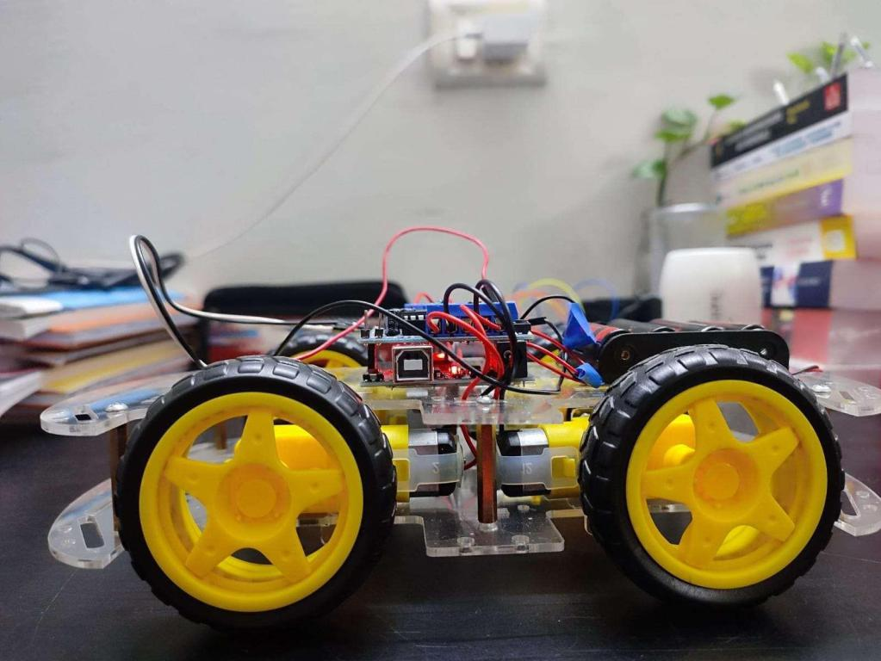

The final product we obtained is just the skeleton of those Remote Control Cars we see in the market. The mechanical design of this product is alsoproposed, which could be practically made to give a much better looking commercial product. For future plans, this product could be added with sensorslike, accelerometer and humidity sensor, thereby widening their field of use.

We could make use of this RC Motor Car as a surveillance system or rovers by adding a few more sensors and updating the code. This would make them into robots. These robots could self monitor under any human supervision, thereby reducing man power. These are just the alternatives, on which this project couldbe improvised and updated.
Conclusion :-

The Bluetooth Automobile with Arduino project is a software programme built utilising the widely used open source platforms Android and Arduino. The project's goal was to build an Arduinointegrated vehicle that requires an android operating system application to operate. The job was successfully finished to everyone's utmost delight. The limitations have been successfully overcome and met. The system styled with the idea that people would find it hard to refuse was set in the design part. Iatrogenic validation tests have significantly decreased mistakes. To upgrade the code, provisions have been made. The application has undergone live data testing and successfully produced a successful outcome. So, the code has demonstrated its ability to think quickly. The system developed achieved its goals, by being straightforward to use, implement and secure.

